See to move between petrol pump we need to know petrol in that petrol pump and distance to next petrol pump. Also we to select min or earliest index that can go circular.

Take this example:

See the petrol tell us the petrol we currently have. Also consider p2 here 6 unit of fuel we have and distance to p3 is 5 unit hence 1 unit more we have. Next p3 to p4 will be 1(earlier fuel left)+7(p3 fuel has)-3(fuel wasted on travelling to p4).now from p4 to p1 will be calculated and we know from same logic that this is possible (4 in excess).now also calculate that from p1 tp p2 possible on same logic and yes. Hence from p2 circular tour is possible.

Next example:

See starting from p1 then at p3 it fails.

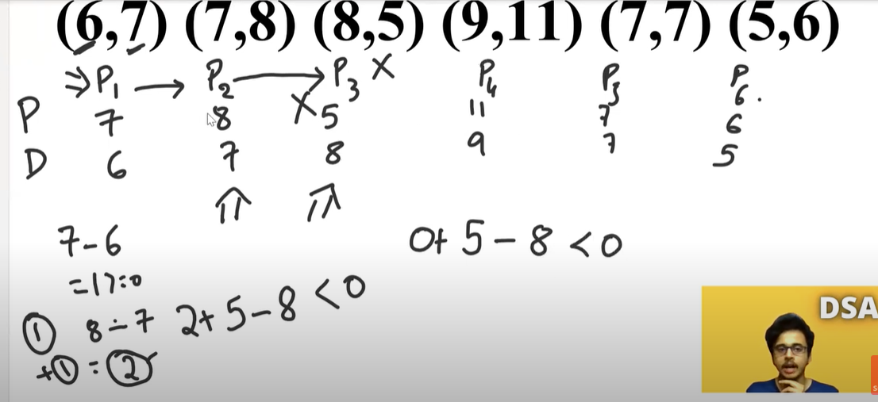

See since we failed from p1 to p3 then in-between p2 or start at p3 not possible.as they themselves not strong enough to transverse. Hence if p1 to p3 fails then p2 and p3 starting not possible. See all value are positive value. Hence start from p4 now.

See we will also take another variable fuel shortage that will tell us how many liters was needed more to complete the journey from p1 to p3.see from p1 to p3 was need 1 unit of more fuel and hence = -1.

See we use fuel shortage as we need to know that p4 to p6 if completed how many more needed from p1 to p3 needed. We will also take fuel tank that will tell us excess fuel from p4 to p6 such that fuel tank>=fuel shortage for tour to be possible.

These 2 values >=0 hence this point can be starting point.

Code:

